Java Console Class->

*The Java Console class is be used to get input from console. It provides methods to read texts and passwords.

*If you read password using Console class, it will not be displayed to the user.

*The java.io.Console class is attached with system console internally. The Console class is introduced since 1.5.

Ex.->

1. String text=System.console().readLine();
2. System.out.println("Text is: "+text);

## **Java Console class declaration**

->

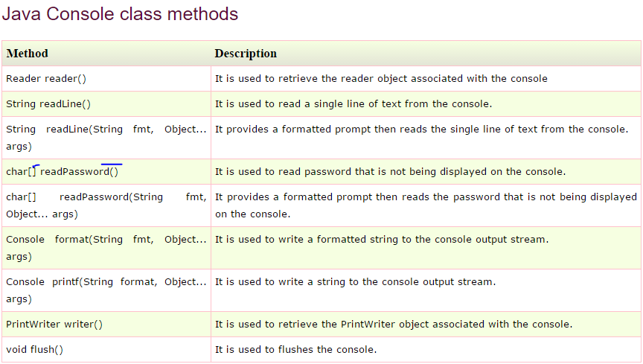

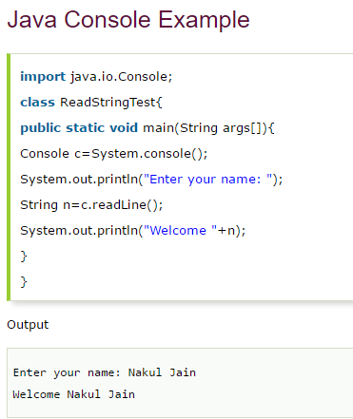

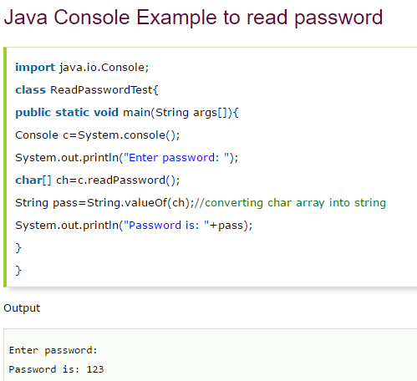

How to set permission File->

If we want to make one text file such as it can only use for reading->

Then we use this..concept

